Media release: 27 January 2021

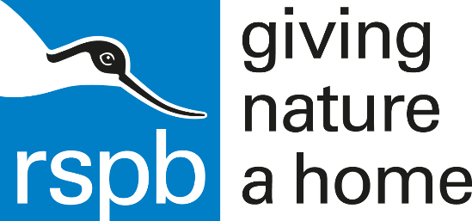
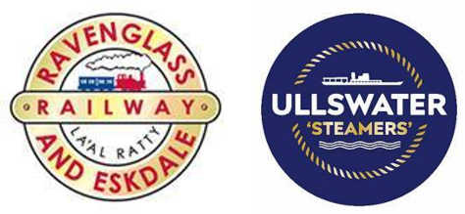

Families invited to support Cumbria’s special wildlife at free RSPB events happening across the county

Families are invited to learn all about Cumbria’s beautiful wildlife, natural habitats, and important local conservation projects – as Lake District Estates teams up with the RSPB to host free educational activities at their popular attractions and holiday parks.

Staff and volunteers from the RSPB will be found at stalls popping up at Lake District Estates’ busiest sites during February and April, including the Ravenglass & Eskdale Railway, the iconic Ullswater ‘Steamers’, Waterfoot Park and Hill of Oaks.
Stalls will be packed with information about Cumbria’s special wildlife and natural habitats, while families can get hands-on and explore their surroundings using the free ‘Wild Challenge’ interactive activities, such as ‘wildlife bingo’.

Pin badges will also be available to purchase and there will be an array of fabulous RSPB children’s magazines available to read such as ‘Wingbeat’, ‘Wild Explorer’ and ‘Wild Times’.

The events kick-off at the Ravenglass & Eskdale Railway in February, as the heritage steam railway prepares to open for two-weeks only during half-term. Visitors will find the RSPB stall at the Railway’s Dalegarth station from 10am – 4.30pm on February 13th, 20th, and 27th.

Jamie Hamilton, Membership Officer at RSPB says, “Families can expect to be wowed by the displays found on our stands at LDE sites this February and April. We encourage you to come and talk to one of our friendly staff members about all of the important conservation work taking place over Cumbria. We are passionate and knowledgeable about giving nature a home, please don’t hesitate to ask us any questions you might have!”

Rachel Bell, Head of Marketing and Development at Lake District Estates says, “We are delighted to be working with the RSPB at our attractions and caravan parks. The RSPB do amazing work to protect our beautiful birdlife, wildlife and important natural habitats, it’s a great chance for visitors of all ages to appreciate their surroundings, get hands on and engage with nature, and learn how they can get involved with exciting local initiatives.”

RSPB stalls can be found at the following Lake District Estates sites:

Ravenglass & Eskdale Railway – Dalegarth station
- February 13th, 20th, 27th
- April 2nd, 6th, 13th

Ullswater ‘Steamers’ – Glenridding Pier
- April 3rd, 9th, 16th

Waterfoot Park
- April 5th

Hill of Oaks
- April 4th, 11th

ENDS
Notes to Editors:

For further information and media enquiries, please contact:
Holly Collins, Bespoke PR Cumbria Tourism – 07766 985993 / 01539 822 222 hcollins@cumbriatourism.org

